Report Vulnerable Machine: Bluemoon

Reconnaisance ⟶ netdiscover
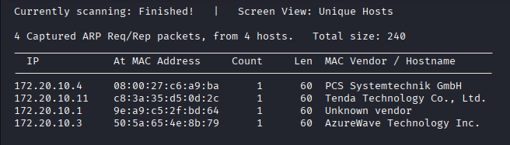

Reconnaisance ⟶ ifconfig
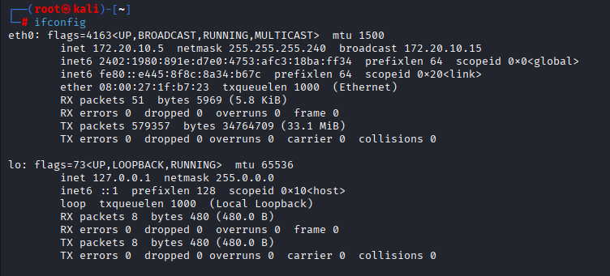

Reconnaisance ⟶ nmap (nmap -sn)
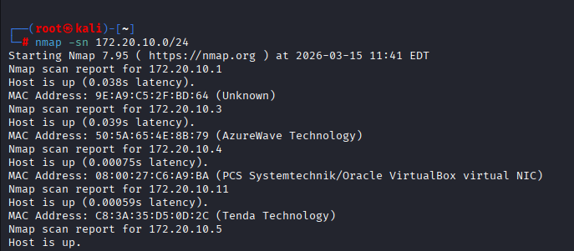
Scanning ⟶ nmap (nmap -sC -sV -Pn -vv 172.20.10.4)
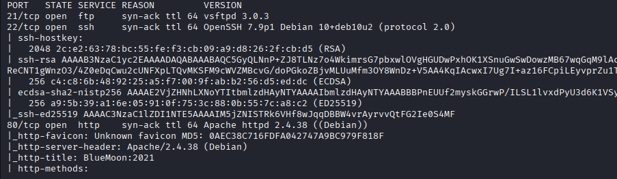

Scanning ⟶ Dirbuster / Dirb/Gobuster
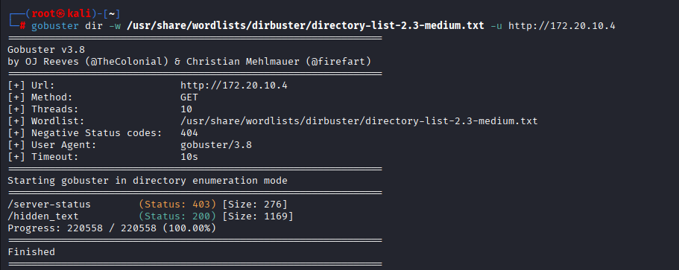

Scanning ⟶ Dirbuster / Dirb/Gobuster Command: dirb http://192.168.115.129 ~/Desktop/wordlist.txt -X .php,.html,.txt
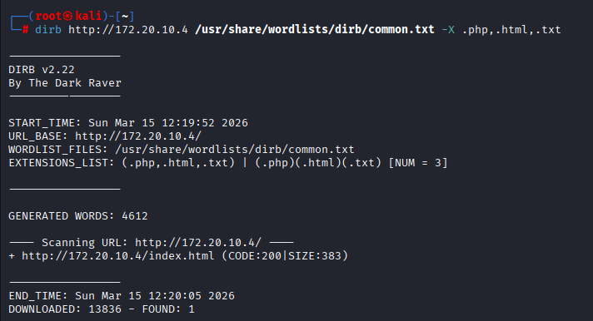

Scanning ⟶ Dirbuster / Dirb/Gobuster

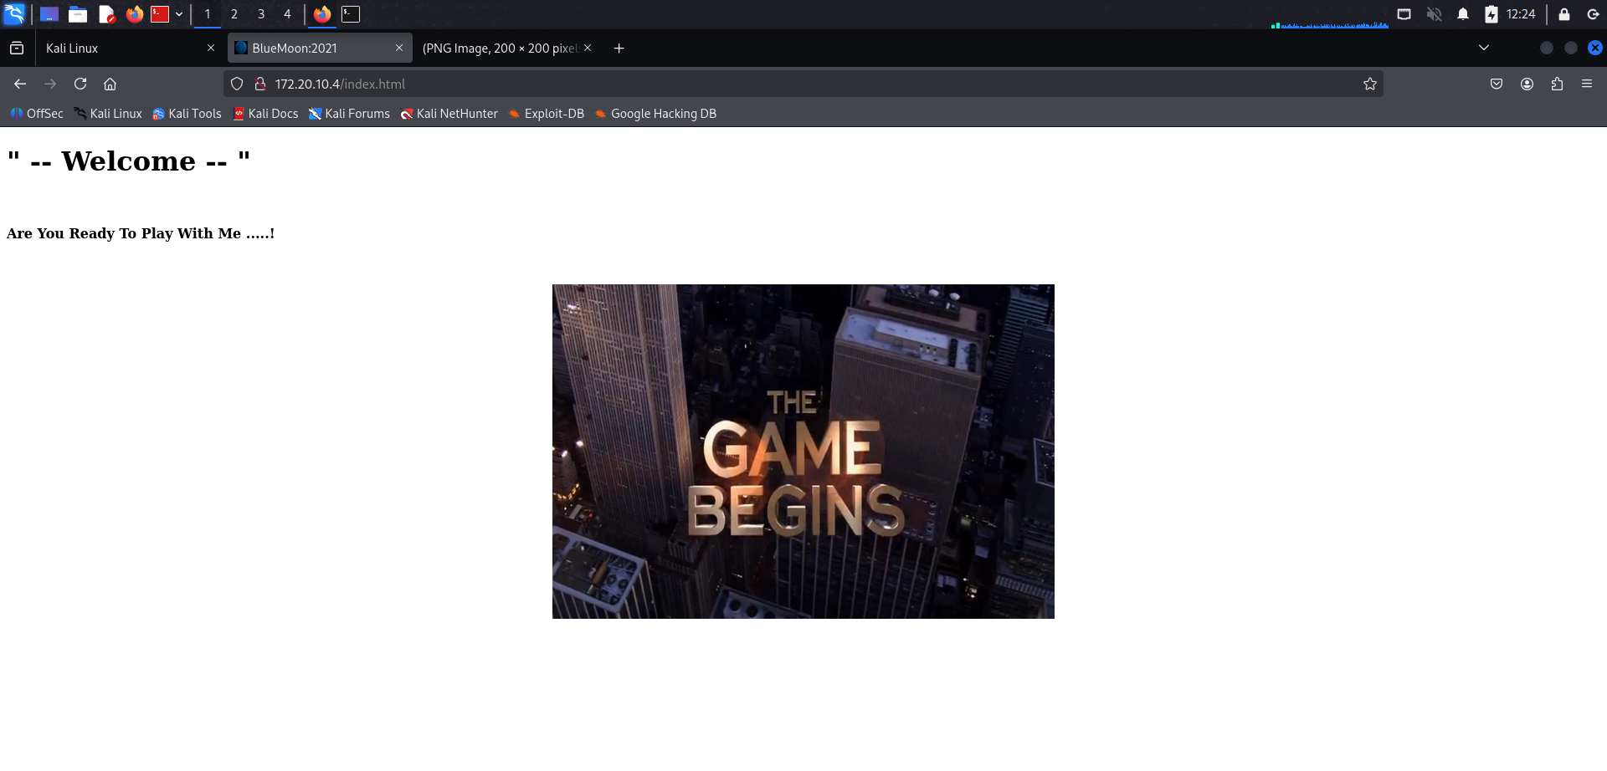
After we insert 172.20.10.4//hidden_text in browser it show like this
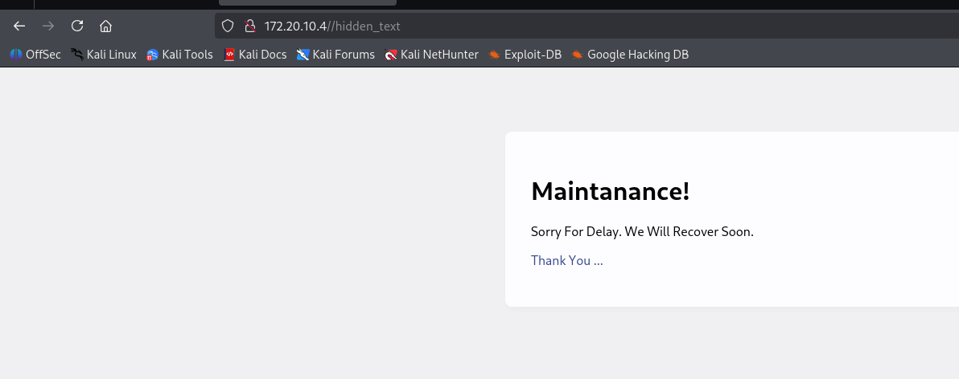
This is After We view page source of the above site
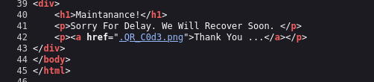

We found this qr code link
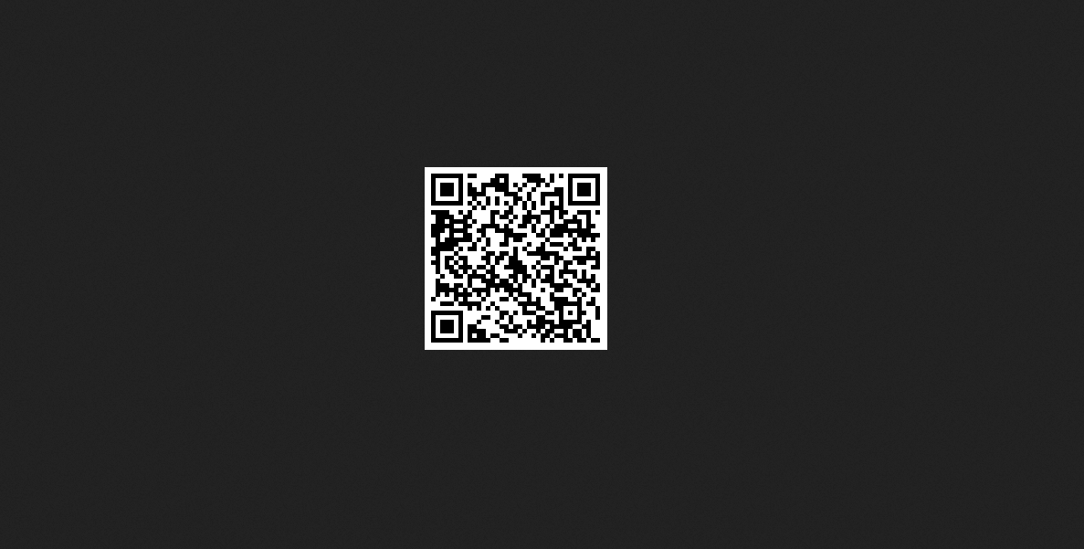
this contain in the qr cod :
#!/bin/bash

HOST=ip
USER=userftp
PASSWORD=ftpp@ssword

ftp -inv $HOST user $USER $PASSWORD
bye
EOF

We Enter Username and password that we got from that qr code
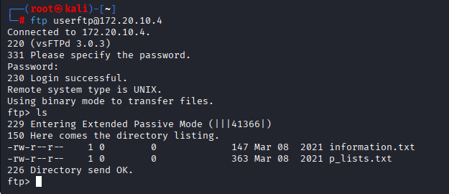

We extract the file information.txt and p_lists.txt
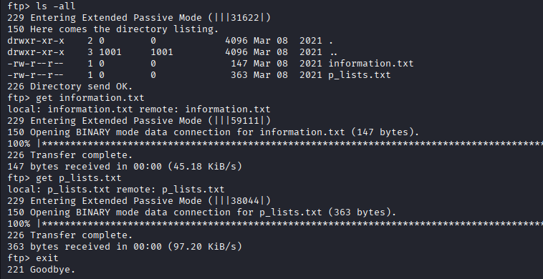

After we get the file we use command “cat” to view the content of the file
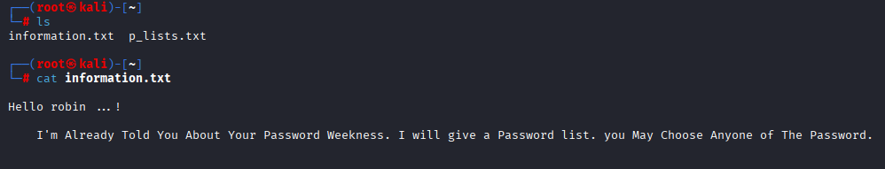

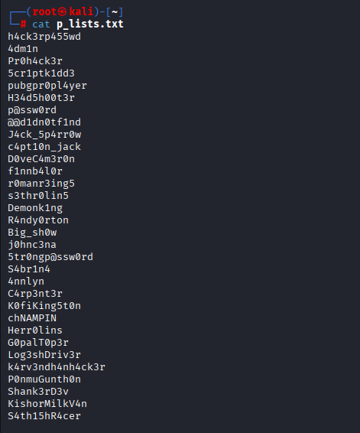

We Use commad “hydra “ to identify the true password
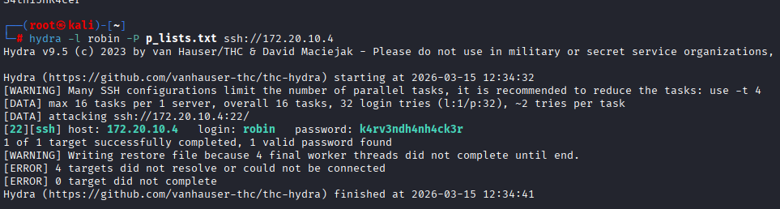

We can get in to the Robin@BlueMoon
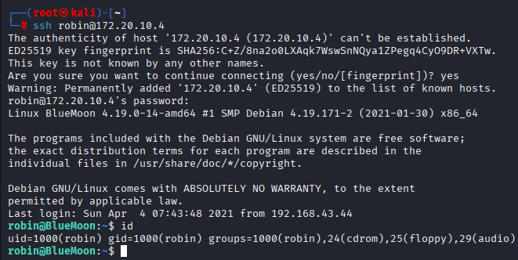
This Is first flag we got
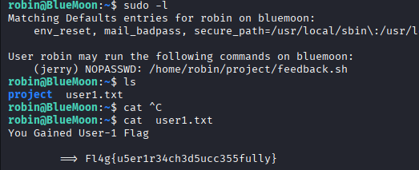

After that, We get into the jerry and get this second flag
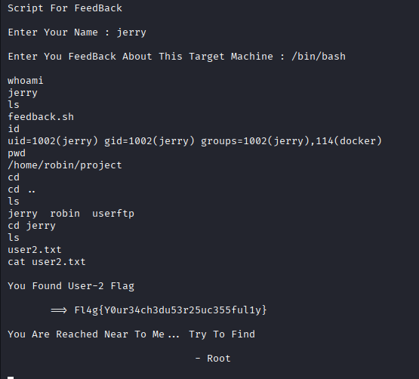

After that we use command this ” python -c 'import pty; pty.spawn("/bin/bash")'” to get a better shell
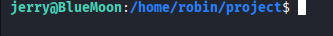

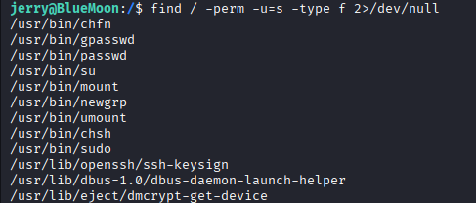

After we get permission into the root , finally we get the third flag
